Great Opportunity for Future Researchers/PhD Candidates!
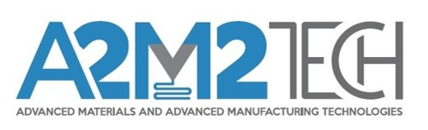

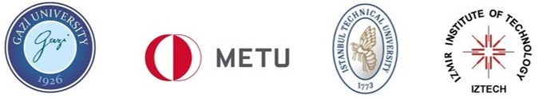

We are seeking 22 Ph.D. candidates, called early-stage researchers (ESRs) to work under the project titled A2M2TECH (Doctoral Programme in Advanced Materials & Advanced Manufacturing Technologies). The aim of A2M2TECH is to deliver an interdisciplinary, inter-sectorial and international excellence doctoral training programme in all aspects of advanced manufacturing and advanced materials, with a major focus on additive manufacturing and related technologies. The programme brings together various strong laboratories and research centers in order to run a collaborative Ph.D. programme in the fields of Advanced Materials and Advanced Manufacturing Technologies. The programme is co-founded by European Commission (ec.europa.eu) and the Scientific and Technological Research Council of Turkey (TÜBİTAK) (tubitak.gov.tr). 22 ESR will be doing their PhD at one of the following top research universities in Turkey:
Gazi University (GU) (gazi.edu.tr/view/Index),
Middle East Technical University (METU) (metu.edu.tr/),
İstanbul Technical University (ITU) (itu.edu.tr/en/)
İzmir Institute of Technology (IZTECH) (en.iyte.edu.tr/).
All universities as part of the Programme have cutting-edge technologies and have modern working environment with a view to enhancing the performance of the ESRs.

Through this programme, you have the opportunity to grow academically and also built your career in industry at the same time. Once you are selected and qualified as one of our Early Stage Researchers (ESRs), you will also be part of a wide range of scientific networking of the hosting top research organizations/universities and research centers. The package for ESRs is generous (gross salary of €2920 per month.) and well organised in terms of income and richness of learning opportunities. After completing the Ph.D., ESRs will have a chance to get employment at spin off companies and technology companies at TechnoHAB (teknohab.com.tr) and/or even startup their own company to exploit the results generated in their research project during the programme.

For further information on eligibility and application process please visit A2M2TECH website: a2m2tech.org.tr The deadline for application is 30 November 2021.

